Amazon Web Services
S3
Amazon S3 is a cloud storage service that lets you store and retrieve any amount of data at any time.
It is one of the most commonly used services in AWS.

Screenshot 1 – Public Bucket Creation
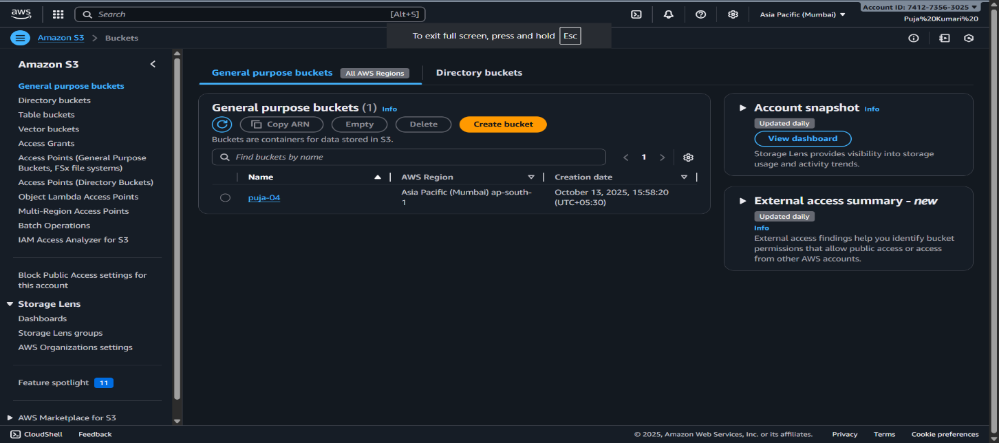
Explaination:
- Opened the Amazon S3 dashboard showing your bucket puja-04.
- Displays bucket region and creation date.
- From here, we can manage or configure the bucket.
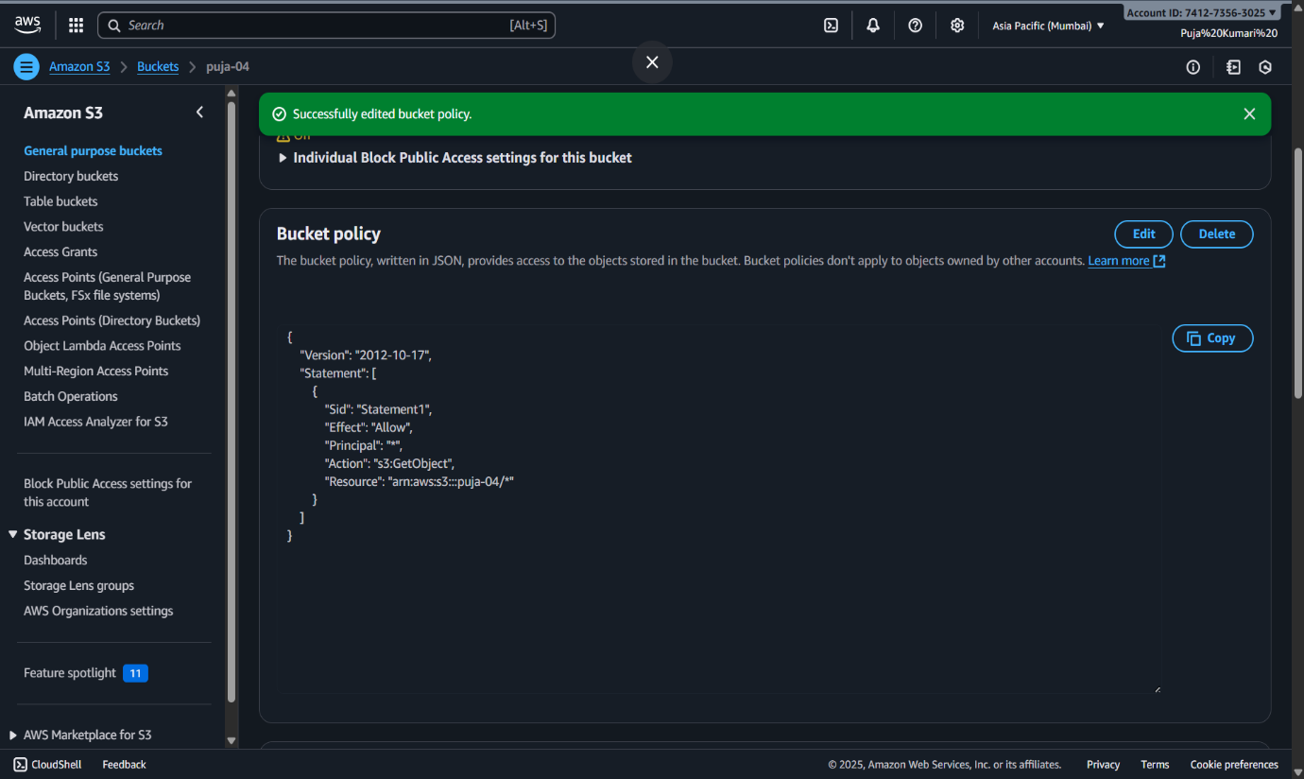
Screentshot 2 – Bucket Policy Configuration
Explaination:-
- You opened the Bucket Policy section for bucket puja-04.
- A success message shows that the bucket policy was edited correctly.
- The JSON policy displayed grants public read access (s3:GetObject) to all objects in the bucket.

